<Whatscamp>

<DESIGN Manual>

Purpose of the document

The purpose of this document is to describe the Design of WhatsCamp to the user

Contents

Purpose of the document 1

1. General Description 3

1.1 Brief description 3

1.2 Project players 3

1.3 Support 3

1.4 Address 3

1.5 Authentication 3

1.6 System Requirement 3

2. Design Elements 4

2.1 General Layout 4

2.2 Icons 4

2.2.1 SIzing 4

2.3 Colors 5

2.4 TYPOGRAPHY 6

2.4.1 FONTS 6

2.5 ANIMATION 8

2.6 TOOL TIPS 9

3. References 10

# General Description

## Brief description

The purpose of this design manual is to establish uniform design to assist the developer for designing the program. This manual uses the principles of Human Computer Interaction to help the visualizing what is a good design for mobile application.

## Project players

WhatsCamp is developed by Informatics student at Universitas Pelita Harapan for Human Computer Interaction project.

- Alvin Christianto Callysta, 00000012551

- Cika Desela P.M, 00000011818

- Clarissa Veronica Kusuma, 00000013004

- Jessica Sean, 00000013452

- Joseph, 00000013230

- Keren Angelia Raintung, 00000013847

- Kevin Kurniawan, 00000014200

## Support

You can contact us through [WhatsCamp.support@gmail.com](mailto:WhatsCamp.support@gmail.com) for support.

## Address

WhatsCamp requires internet connection and GPS to be accessed.

## Authentication

WhatsCamp requires authentication in order to be used. Authentication can be done by using Facebook or Google Plus account.

## System Requirement

Minimum System Requirement:

1. Android OS: Nougat (API 24)

2. CPU: 1.5 Ghz Dual-core

3. RAM: 512 MB

4. Storage: at least 25 MB

5. Permissions: GPS-enabled.

# Design Elements

## General Layout

In general, the layout for WhatsCamp consists of icons, shapes, colors, and animations. Elements outside the WhatsCamp app will not be covered in this design manual.

## Icons

Here, WhatsCamp uses rounded square shapes as its icon shapes because rectangles with rounded corners are easier on the eyes than a rectangle with sharp edges because they take less cognitive effort to visually process [1]. Thus, rectangles with rounded corners are easier to process because they look closer to a circle than a regular rectangle.

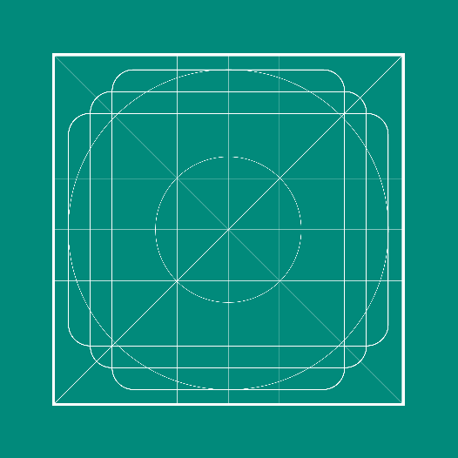

**Picture 1.** Rounded Square [2]

### SIzing

Icon size is set to 24-dp in our application.



**Picture 2.** WhatsCamp Icon [3]



**Picture 3.** WhatsCamp logo

Form shapes variation is set to 24-dp for height, match parent for weight and and padding to 5-dp in our application.

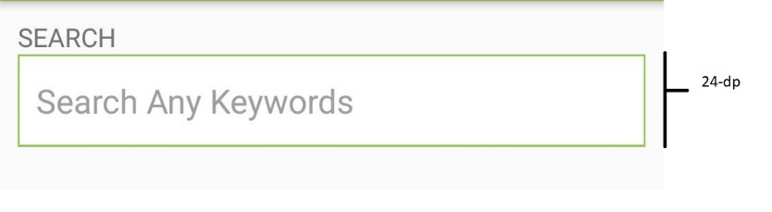

**Picture 15.** Form shapes on search

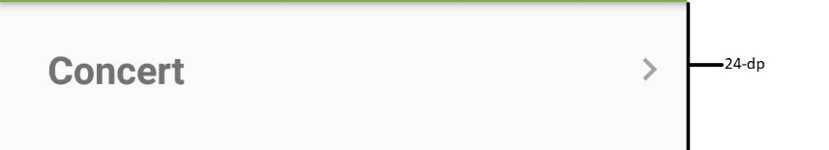

**Picture 16.** Form shapes on category

## Colors

WhatsCamp uses the following color palettes for the main theme as seen on Picture 3 and Picture 4.

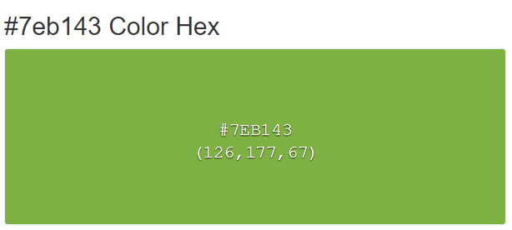

**Picture 4.** #7eb143 as main color for WhatsCamp [4]

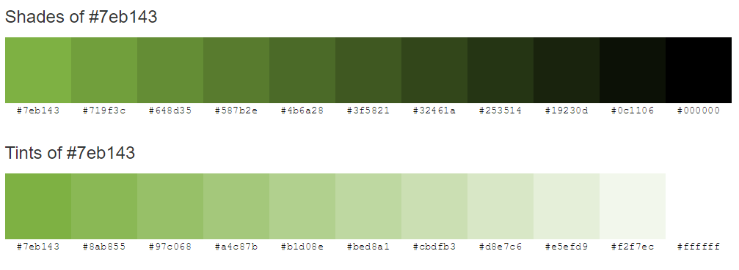

**Picture 5.** Color palette for WhatsCamp [4]

For our icons, we use analogous color scheme which is match well and create serene and comfortable designs. Analogous color schemes are often found in nature and are harmonious and pleasing to the eye [5].

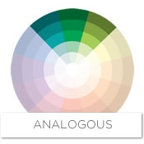

**Picture 11**. Analogous color scheme blue-green. [6]

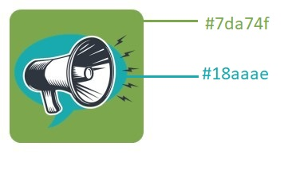

**Picture 14.** Icon color details

## TYPOGRAPHY

### FONTS

We use Roboto, which is the default font family in Android. Roboto font features friendly and open curves, allowing letters to be settled into their natural width. This makes for more a natural reading rhythm more commonly found in humanist and serif types [7]. Roboto, with the following typefaces:

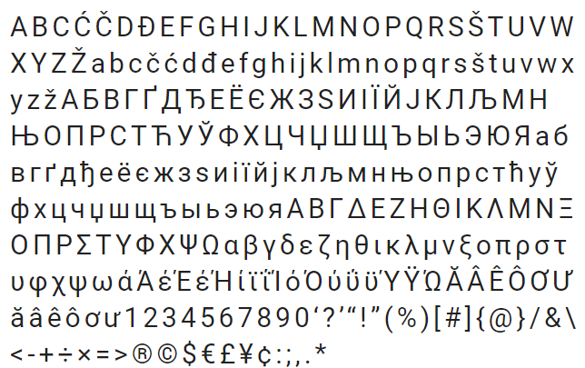

**Picture 6.** Roboto characters [7]

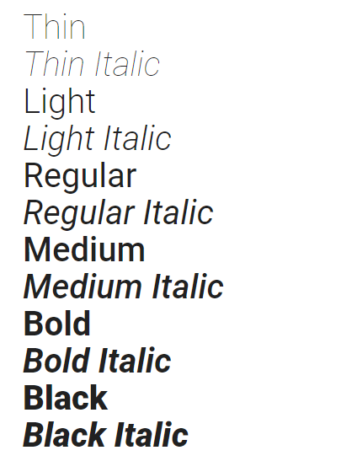

**Picture 7.** Roboto styles [7]

## ANIMATION

Animation are used in WhatsCamp. The animation that we use here are in the navigation drawer, which is a panel that displays the app’s main navigation options on the left edge of the screen. It is hidden most of the time, but is revealed when the user swipes a finger from the left edge of the screen or, while at the top level of the app, the user touches the app icon in the action bar [8]. Navigation drawer is one of the default activities that Android Studio provides, so we don’t have to worry much about the animation, because Android Studio will take care of it for us. The animation that we mention here are when the user swipes a finger from the left edge, and then the navigation drawers will slides in. Navigation drawer in WhatsCamp are shown below.

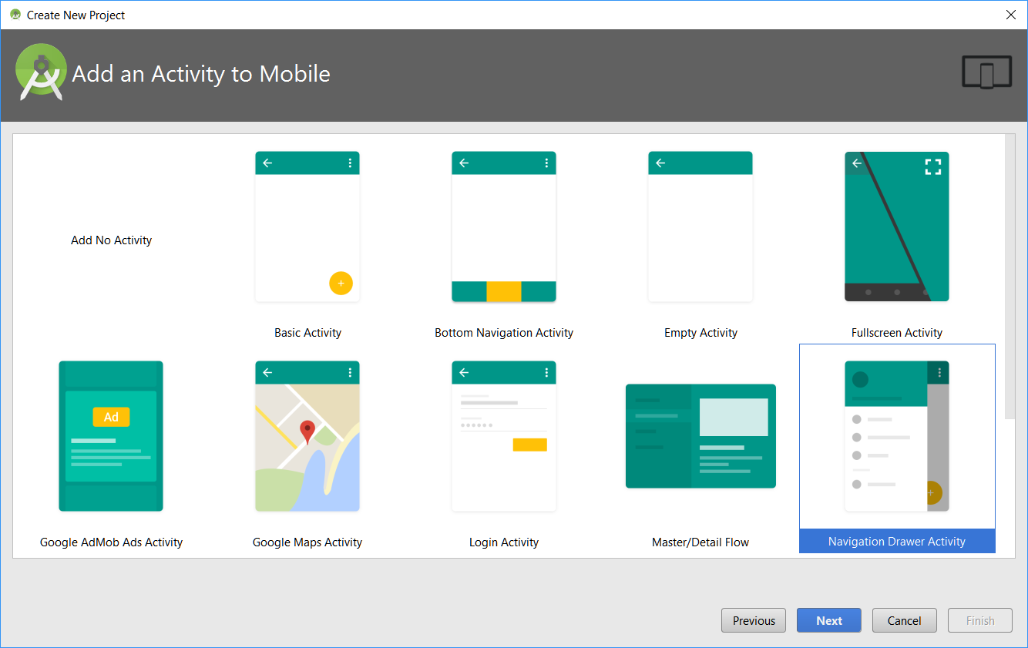

**Picture 8**. Navigation Drawer, one of the default activities in Android Studio

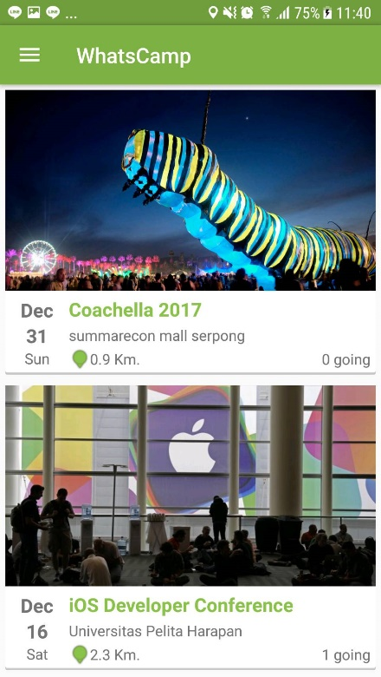

**Picture 9**. Before Navigation Drawer are Shown

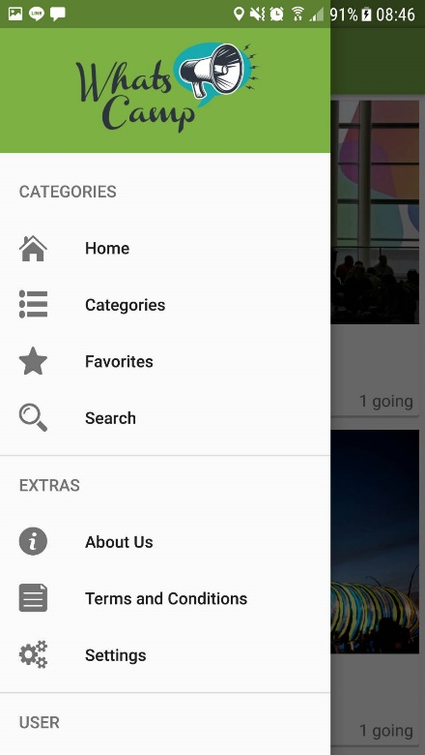

**Picture 10**. Navigation Drawer are Shown in WhatsCamp

## TOOL TIPS

For helping user to know the used of button, we use Tool Tips to pop up message with information about what the button used for. This Tool Tips will be shown when you hold certain button for long time. Tool Tip message will be popped up by adjusting its location. If the button placed on bottom of the screen, it will popped up to above, and if it placed in the middle of the screen or on top it will popped up below [9]

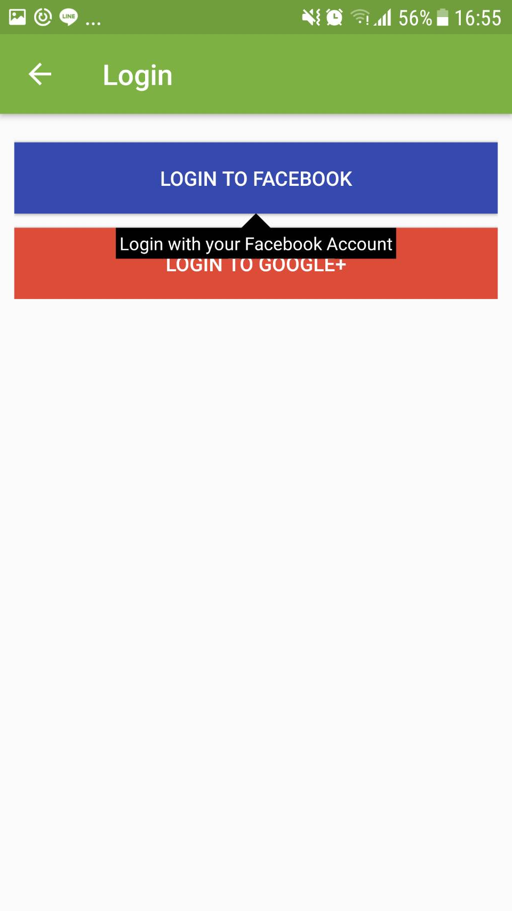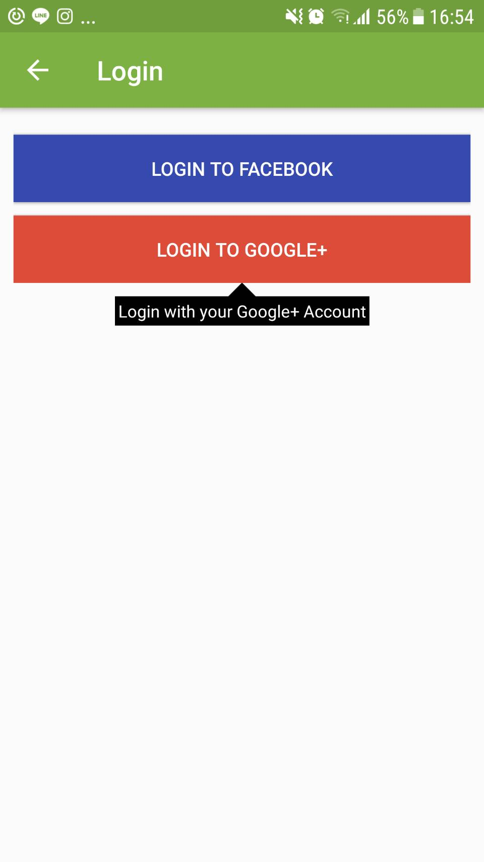

**Picture 12.**  Tool Tip on “Login to Facebook” **Picture 13.**  Tool Tip on “Login to Google+ Account”

# References

|  |  |
| --- | --- |
| [1] | Anthony, “Why Rounded Corners Are Easier on the Eyes,” 11 August 2017. [Online]. Available: http://uxmovement.com/thinking/why-rounded-corners-are-easier-on-the-eyes/. [Accessed 5 December 2017]. |
| [2] | [Online]. Available: http://img.zcool.cn/community/02b443594bd802a8012193a3122255.png. [Accessed 5 December 2017]. |
| [3] | “calltoaction_logo_icon-1.png,” [Online]. Available: http://www.calltoactionmedia.com/wp-content/uploads/2015/08/calltoaction_logo_icon-1.png. [Accessed 21 October 2017]. |
| [4] | “#7eb143 Color Hex,” [Online]. Available: http://www.color-hex.com/color/7eb143. [Accessed 15 November 2017]. |
| [5] | “Basic color schemes - Introduction to Color Theory,” [Online]. Available: http://www.tigercolor.com/color-lab/color-theory/color-theory-intro.htm. [Accessed 5 December 2017]. |
| [6] | “CS_SI_DS_ColorStoryDecoratingWithGreen_S4_CW_Analogous,” [Online]. Available: https://raymourflanigan.scene7.com/is/image/RaymourandFlanigan/CS_SI_DS_ColorStoryDecoratingWithGreen_S4_CW_Analogous?scl=1&qlt=100. [Accessed 5 December 2017]. |
| [7] | “Roboto,” [Online]. Available: https://fonts.google.com/specimen/Roboto. [Accessed 15 November 2017]. |
| [8] | “Creating a Navigation Drawer | Android Developers,” [Online]. Available: https://developer.android.com/training/implementing-navigation/nav-drawer.html. [Accessed 5 12 2017]. |
| [9] | “The Android Arsenal - ToolTips - Simple Tool Tip,” [Online]. Available: https://android-arsenal.com/details/1/2526. [Accessed 5 December 2017]. |